Insomnia
# Source: Chatgpt (GPT-4-turbo) at [6/24/2025]
Insomnia is a modern, open-source API client used for designing, testing, debugging, and documenting REST, GraphQL, and gRPC APIs. It offers many of the same features as Postman but with a streamlined, developer-friendly interface and a focus on productivity.

🔍 Key Features of Insomnia
# Source: Chatgpt (GPT-4-turbo) at [6/24/2025]
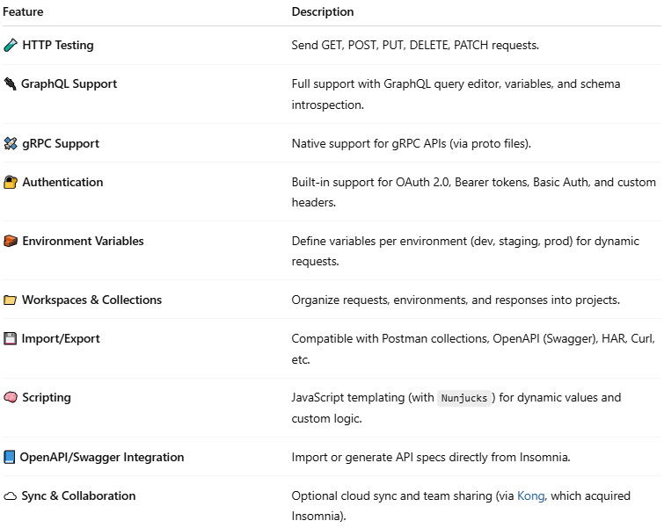

Feature | Description
🧪 HTTP Testing | Send GET, POST, PUT, DELETE, PATCH requests.
🔌 GraphQL Support | Full support with GraphQL query editor, variables, and schema introspection.
🛰️ gRPC Support | Native support for gRPC APIs (via proto files).
🔐 Authentication | Built-in support for OAuth 2.0, Bearer tokens, Basic Auth, and custom headers.
🧱 Environment Variables | Define variables per environment (dev, staging, prod) for dynamic requests.
📁 Workspaces & Collections | Organize requests, environments, and responses into projects.
💾 Import/Export | Compatible with Postman collections, OpenAPI (Swagger), HAR, Curl, etc.
🧠 Scripting | JavaScript templating (with Nunjucks) for dynamic values and custom logic.
📘 OpenAPI/Swagger Integration | Import or generate API specs directly from Insomnia.
☁️ Sync & Collaboration | Optional cloud sync and team sharing (via Kong, which acquired Insomnia).

🆚 Insomnia vs Postman
# Source: Chatgpt (GPT-4-turbo) at [6/24/2025]
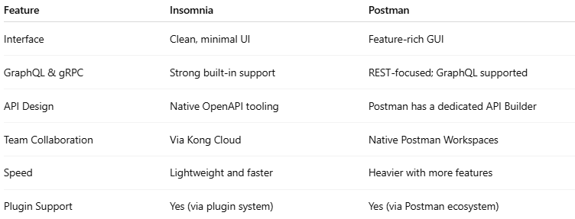

Feature | Insomnia | Postman
Interface | Clean, minimal UI | Feature-rich GUI
GraphQL & gRPC | Strong built-in support | REST-focused; GraphQL supported
API Design | Native OpenAPI tooling | Postman has a dedicated API Builder
Team Collaboration | Via Kong Cloud | Native Postman Workspaces
Speed | Lightweight and faster | Heavier with more features
Plugin Support | Yes (via plugin system) | Yes (via Postman ecosystem)

📌 Example: Simple REST Request
# Source: Chatgpt (GPT-4-turbo) at [6/24/2025]
- Open Insomnia
- Click + New Request
- Set method to GET, and URL:
https://jsonplaceholder.typicode.com/posts/1
- Click Send
- See JSON response in a structured viewer.

⚙️ Use Cases
# Source: Chatgpt (GPT-4-turbo) at [6/24/2025]
- Testing APIs in development
- Exploring third-party APIs
- Working with OpenAPI/Swagger specs
- Testing GraphQL or gRPC endpoints
- Automating repetitive API testing with variables and scripts

Download Insomnia
# Source: Windows ScreenShots at [6/24/2025]
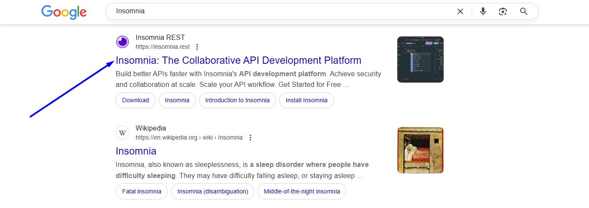
https://insomnia.rest/
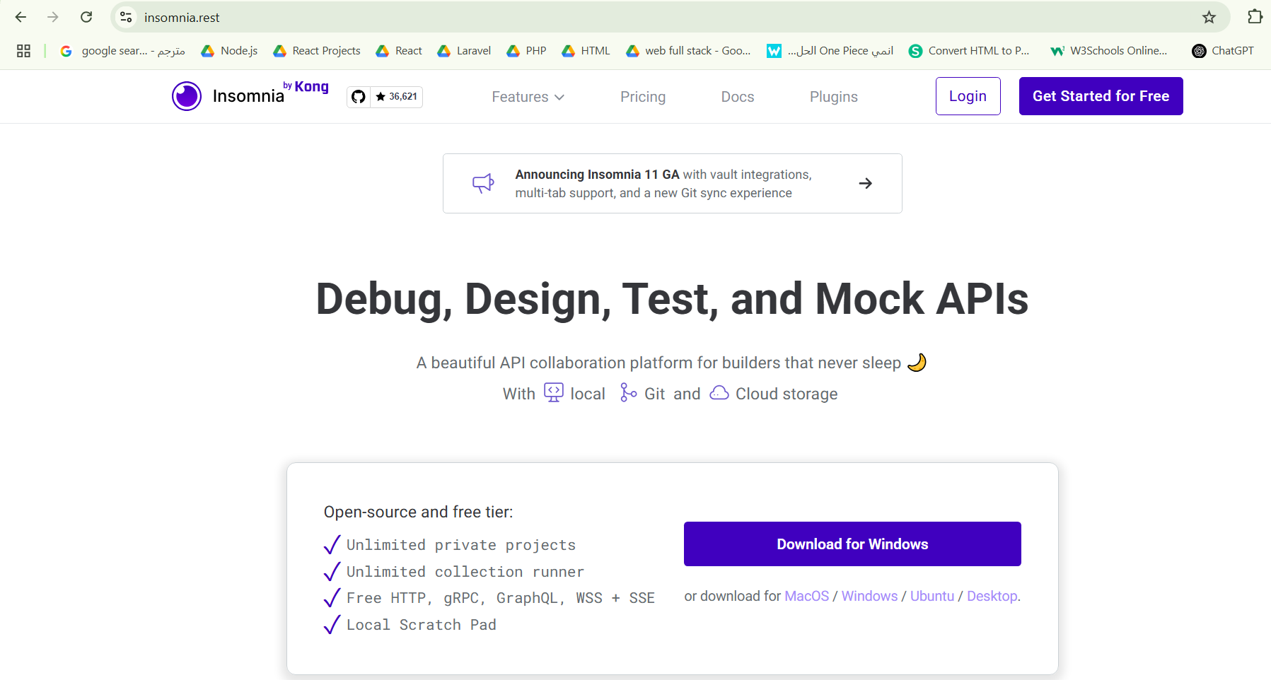
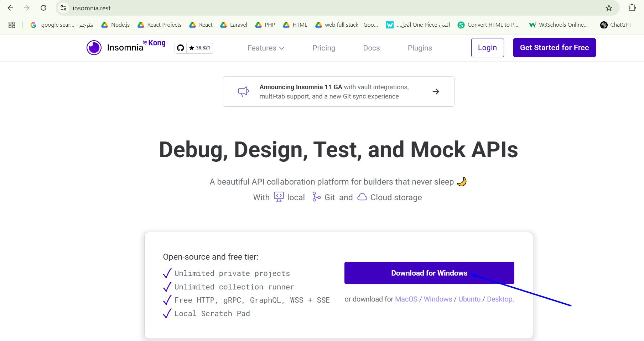

Install Insomnia
# Source: Windows ScreenShots at [6/24/2025]
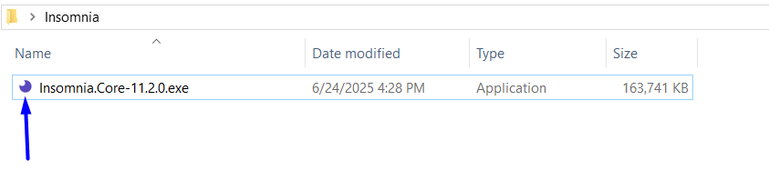

Run Insomnia
# Source: Windows ScreenShots at [6/24/2025]
